NAME: TEJAS NALAWADE PRACTICAL NO: 7 ROLL NO: TCOD01
AIM: Database Trigger (All Types: Row level and Statement level triggers, Before and AfterTriggers).

Problem Statement: Write a database trigger on Library table. The System should keep track of the records that are being updated or deleted. The old value of updated or deleted records should be added in Library_Audit table.

TABLES
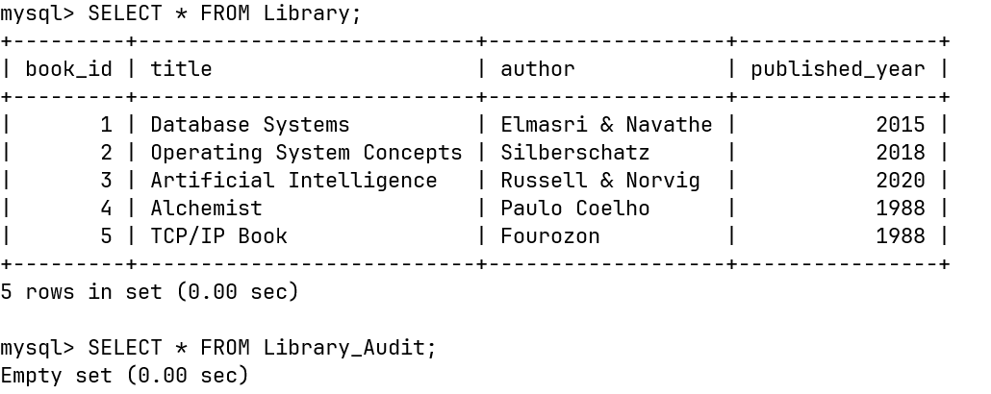

TRIGGER

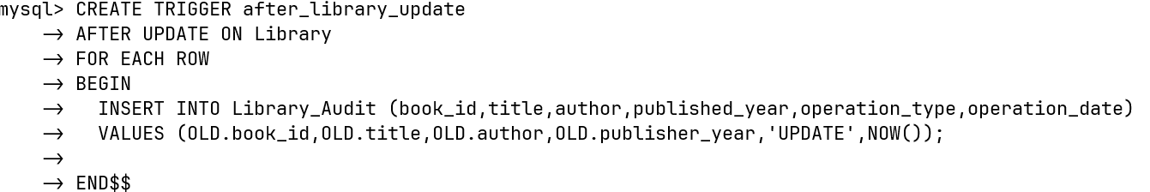
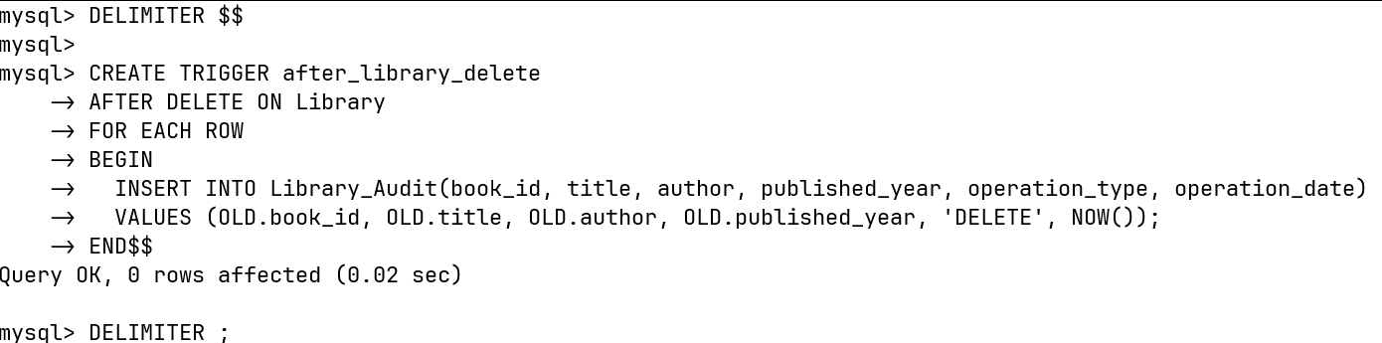

UPDATE
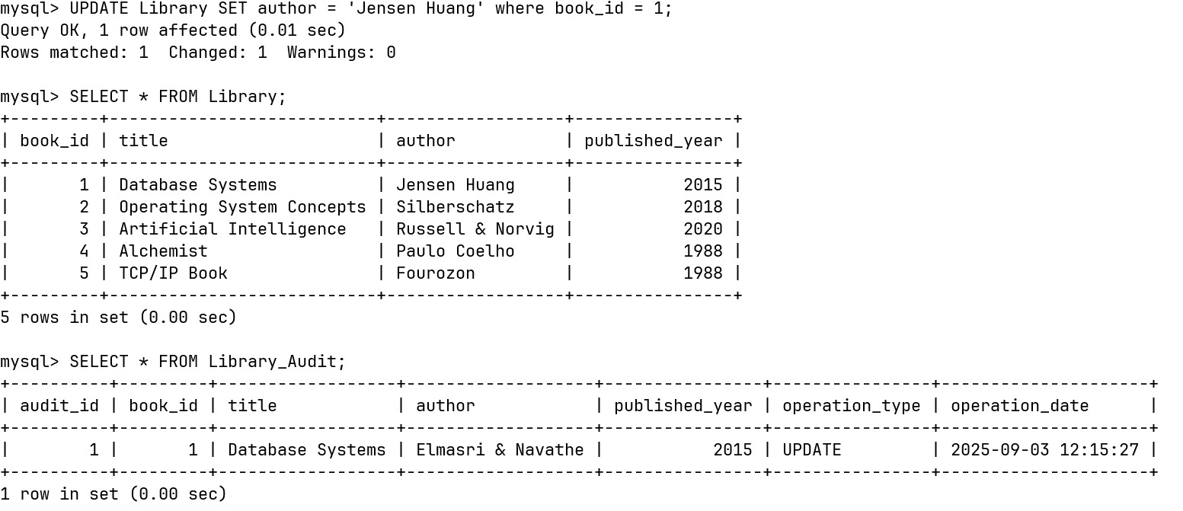

DELETE

